

Course Code  BIOM3333

Course Title   Principles of Biomedical Research

Course Coordinator   Ethan Scott

Due Date  31/10/2014

Assignment Title  The study of *Caenorhabditis elegans* egg laying defect

Word Count 32,543 character count

Date Submitted  31/10/2015

**Extension applied for Yes**  **/ No**  **Revised Date**

|  |  |  |
| --- | --- | --- |
| **Student Number** | **Surname** | **First Name** |
| 42835341 | Zhang | Zhen |



* **The study of *Caenorhabditis elegans* egg laying defect**
* **Cell, Research article format**
* **Character count: 32,543**
* **Number of figures & table: 7**
* **Abstract**
* Unknown mutant of *Caenorhabditis elegans* was provided to characterise the mutant phenotype and to localise the mutant gene. After egg laying assay, drug test assay, light toughing assay, DIC image taken, GFP stains crossing and GFP image taken, it has been summarized about unknown mutant stain that 1) egg-laying defect; 2) resistant to serotonin and imipramine, HNS was functioning; 4) recessive; 5) movement uncoordinated; 6) anchor cell release EFP-liked Lin-3 inductive signal is normal; 7) EFPR-MAPK pathway in VPCs is normal; 8) Lateral LIN-12 inhibition pathway is normal; 9) uterus pi cell lineage is normal 10) as uv1 cell is normal, the connection with uterus and vulva is normal. The further studies need to increase the DIC and GFP images taken, and focused on anchor cell fusion, vulva tubulogenesis and signal transduction involved in muscle contraction.

**Introduction**

* The worm *Caenorhabditis elegans* is the nematode organism model in genetic research, which is a small animal that like other animals has muscle, a nervous system, a digestive system and skin etc. The most gender of *c. elegans* a self-fertilizing hermaphrodites and only 1% of them is male (Newman et al., 1996). *C. elegans* is the first animal which the genome was known, thus availability of the genome mutant in the worm could be experimentally approached for processing gene expression, gene knockout phenotype etc. *C. elegans* is an excellent model research organism. Using *c. elegans* for the study of human biology has a lot benefits, which are the genes in *c. elegans* have close homologues in the human. Many human disease genes exist in the worm gene as well. It would be simple to investigate these human disease genes in c. elegans genome such as obesity, cancer etc. (Blaxter, 2011; Sulston and Horvitz, 1977; Sulston et al., 1983).
* The genetic analysis of *c. elegans* behaviours provides the efficient way to investigate the cellular base of development of nervous system in worm. The egg laying behaviour that involved motor neuron system and smooth muscle cells, which is the best-studied behaviours. In this project, an investigation of egg-laying defective mutants helps understanding the process in development of nervous system which containing neurogenesis, cell migration, and cell signal transduction etc. (Schafer, 2006).
* The egg-laying apparatus contained in reproduction system in *c. elegans* are consisting of vulva, sex muscle (8 vulval muscle, 8 uterus muscle). The motor neuron system involved in egg-laying behaviour contains 6 ventral cord neurons (VCN) and 2 hermaphrodite specific neurons (HSN) (Pazdernik and Schedl, 2013; Schafer, 2006).
* In the *c. elegans’* vulva development, a network of intercellular signalling transduction is the most precise pathway. The only single cell in somatic gonad called the anchor cell is the most significant cell to organize the development of the vulva from epidermal precursors and the connection of vulva and uterus.
* At L1/L2 life stage of *c. elegans*, epidermal precursor cells develop to 6 vulva precursor cells (VPCs, Pn.p). In L3 stage, anchor cell induce the pattern of VPCs fates. Anchor cell releases epidermal growth factor (EGF) LIN-3 to induce 3 proximal of 6 VPCs to adopt their fates. P6.p cell produces DSL ligand to activate receptor LIN-12 (Notch) lateral pathway to inhibit the nearby VPCs development and form 3 different fates in 6 VPCs (1°fate: P6.p; 2°fate: P5.p and P7.p; 3°fate: P3.p, P4.p and P8.p). At L4 stage of *c. elegans*, VPCs are divided to 22 vulva mature cells (VulF, E etc.) (Dutt et al., 2004; Ranawade et al., 2013; Sharma-Kishore et al., 1999; Yoo et al., 2004).
* In addition, anchor cell is developed from one of two AC/VU cells. LIN-12 Notch signalling pathway mediate another AC/VU cell becomes three ventral uterus (VU) precursor cells and then generate 12 grand-progeny in L2/L3 stages. After that at L3 stages of *c. elegans.* 6 of them induced by anchor cell to be 6 uterus pi cells to adopt the pi fate. At L4 stage, 4 pi cells will induced by EGF-lin13 that released by vulva cell (VulF) to form 4 uterine vulval (uv) 1 cells (on each side), and tight connect with the VulF help connect the uterus with vulva. Rest of 8 cells will arrange to utse (on each side) for anchor cell fuse with(Alkema et al., 2005).
* In 1° lineage of vulva development, uv1 tightly connect with VulF and anchor cell response to the signal from VulF cells to locate them help tubulogenesis, finally, anchor cell breaks basement membrane and fuse into utse for developing 1° lineage. (Cinar et al., 2003; Newman et al., 1996; Ranawade et al., 2013).
* The investigation of development study in *c. elegans* can help to further realize and identify the regulation process in variety of signal transduction pathway (Bettinger et al., 1997; Dutt et al., 2004; Sternberg, 2005).
* *C. elegans* start to accumulate about 10-15 fertilized eggs in the uterus at the beginning of L4/adult molt. In the meantime, egg-laying behaviours process along with muscle contraction and vulva opening to allow eggs laid (Schafer, 2006). Thus, it has been found about 145 fertile mutations in the defect of egg laying behaviour, which generally happen in neuromuscular signal transduction, muscle function, and vulva morphology (Trent et al., 1983).
* Many of neurotransmitter in human can be found in *c. elegans* hermaphrodites, such as 5-HT (serotonin) released by HSNs to stimulate egg-laying behaviours, then acetylcholine (ACh) is further required to enhance egg laying in response to 5-HT (serotonin). After that, 16 muscle cells (vulval muscle & uterus muscle) connected with gap junction that accept neurotransmitter from HSNs to allow muscle contraction and push fertilized eggs out via vulva (Weinshenker et al., 1995).
* To investigate the characteristic of mutant in *c. elegans*, pharmacological agents usage is the efficient method. Thus administering exogenous serotonin and imipramine (serotonin re-uptake inhibitor) help to characterise the mutant in egg-laying defect (Trent et al., 1983). The four categories had been determined based on Trent et al. (1983) that, 1) Egg-laying defect mutation resistant to both serotonin and imipramine, which means vulva morphology, and muscles possible cause the defect but not neuron system; 2) Mutation sensitive to serotonin but resistant to imipramine, which means is HSNs defect that cannot release serotonin; 3) Mutations sensitive to both serotonin and imipramine, which means defects possible happened in motor neuron signalling transduction; 4) Mutation sensitive to imipramine but resistant to serotonin, which means it probably happen in *egl*-2 and *egl*-19 mutation that hypersensitive to imipramine (Trent et al., 1983).
* Furthermore, since it is transparency that enables to visualize the egg-laying defect under optics microscope. Moreover, the green fluorescent protein (GFP) gene can be genetically transformed via microinjection to localise gene function and help investigate mutant phenotype under fluorescent microscope(Chalfie et al., 1994; Fire, 1986).
* In this project, unknown mutant of *c. elegans* was provided, and the aim of the project was to characterise the mutant phenotype and localise mutant gene via several analysing assay.
* **Results**
* **The unknown mutant is egg-laying defect.**
* In order to determine whether of the mutant was egg-laying defect. Egg laying assay was perform. It can be seen below that in Fig. 1, wild type worms (WT), which were N2 worms can lay larger amount of eggs than unknown mutant stain worms (p value=0.0047, <0.05). Furthermore, the few eggs were laid in unknown mutant stain and all of eggs were at late stage (lima bean or pretzel) and few L1 worms were pushed out in unknown mutant stain as well. In contrast, in N2 stain, a certain amount eggs (n=10-15) were laid, and most of them are at early stage eggs (gastrula or coma).
* 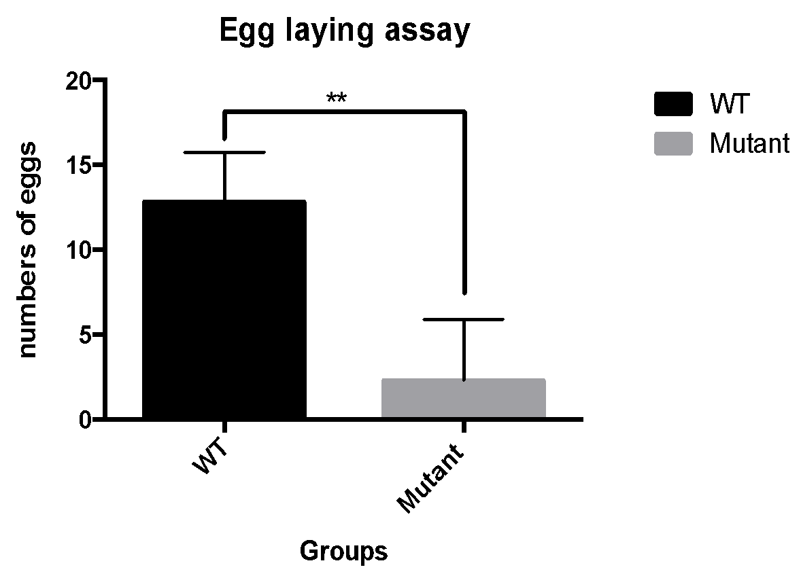
* **Fig. 1 The result of egg laying assay, mean= ±SEM, N=12 for both groups. Mutant has significant reduction of eggs laid compared with wild type. Unpaired student’s t-test. GraphPad Prism 6.**
* **The egg-laying defect mutant is resistant to serotonin and imipramine.**
* Using serotonin and imipramine as pharmacological agents to characterise the mutant and M9 buffer as control. The result clearly analysed by Two-Way ANOVA, the mutant was resistant to both agents that no eggs were laid after worms being treated by drugs, which significantly different with the response in N2 worms that worms laid many eggs after treatment (p<0.0001). In the meantime, both groups of the mutant worms were treated by two drugs did not have significant difference compared with the control worms group that was treated by M9 buffer (p<0.05).
* 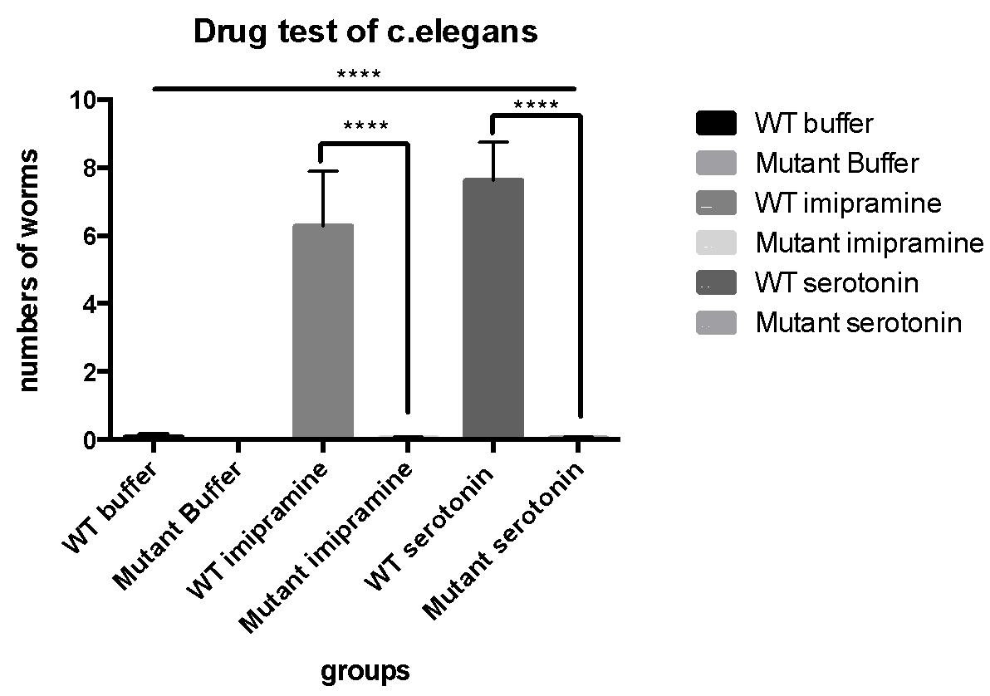
* **Fig. 2 The response of worms to pharmacological agents, mean= ±SEM, N=24 for each groups. Mutant strains have no response to serotonin, imipramine and buffer, significantly different with N2 stains (****= p<0.0001). Two-Way ANOVA. GraphPad Prism 6.**
* **The vulva protruding in the adult mutant *c. elegans.***
* DIC images were taken for N2 and mutant worms at early L4 stages (Fig. 3C&D). The DIC images used in imageJ to measure the diameter of vulva (Fig. 3E), and after three times measurements, and using analysed by unpaired student’s t-test, there was no significant difference between the diameter of vulva in early L4 vulva in N2 and mutant worms. However, the comparison between N2 and mutant worms in adult stage, vulva is apparently protruded in mutant worm (Fig. 3A&B). According to unpaired student’s t-test that for the diameter of vulva, the vulva in mutant worm was significant longer than N2 worm’s vulva (Fig. 3F). Moreover, the angles of vulva protrusion were measured in wild type and mutant *c. elegans* (Fig. 3G). There was significant larger angle of vulva protrusion in the mutant stain than in N2 stain.
* 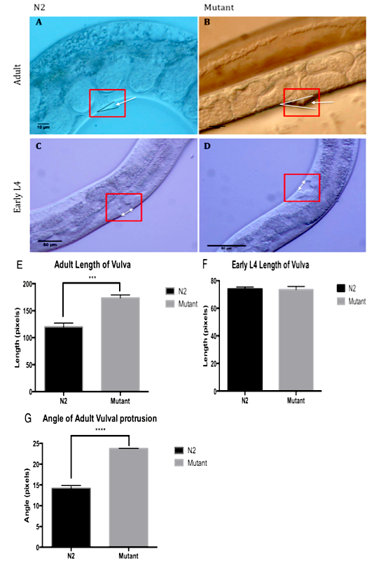
* **Fig. 3 A) Differential interference contrast (DIC) images of N2 adult hermaphrodites, the normal vulva had been labelled, B) DIC image of mutant adult hermaphrodites, the vulva protrusion was showed C) DIC image of N2 early L4 hermaphrodites, vulva was normal. D) DIC image of mutant early L4 hermaphrodites, normal vulva lumen. E) The diameter of vulva had been measure 3 times by imageJ form (Fig. 3A&B) DIC images. Unpaired student’s t-test analyzed by GraphPad Prism 6, the comparison of diameters of vulva between N2 adult hermaphrodites and mutant adult hermaphrodites, ****= p<0.0001, significant difference, mean= ±SEM. F) The diameter of vulva had been measure 3 time by imageJ form (Fig. 3C&D) DIC images. Comparison of diameters of vulva between N2 early L4 hermaphrodites and mutant early L4 hermaphrodites. P>0.05, no significant difference, unpaired student’s t-test, mean= ±SEM, G) The angles of vulva had been measure 3 times by imageJ from (Fig. A&B). Angles of adult vulva protrusion between N2 adult stain and mutant adult stain, ****= p<0.0001, significant difference, unpaired t-test, mean= ±SEM.**
* **Uncoordinated behaviour in egg laying defect *c. elegans.***
* The result of light touching assay showed in Fig. 4 to observe the coordinated behaviours and uncoordinated behaviours. The results showed the significant difference between mutant young adult hermaphrodites and N2 young adult hermaphrodites, most of uncoordinated worm had been found in mutant groups, the uncoordinated movement is the phenotype of mutant stain.
* 
* **Fig. 4 The single blind light touch test assay in response on N2 and mutant *c. elegans* hermaphrodites. Mann-Whitney test performed by using GraphPad Prism 6; ****= p<0.0001, n=30.**
* **MH1317 GFP stain shows the uterus pi cell lineage in different stage of *c. elegans.***
* MH1317 GFP stain is the GFP gene in *egl-13* and *Unc-119 (+)* to mark uterus pi cell lineage and body wall muscle cell in *c. elegans.* In the N2 L3 worm (Fig. 5A), there are 12 cells had been marked by GFP, these cells are 12 grand-progeny cells divided from 3 ventral uterus (VU) precursor cells. In the mutant L3 worm (Fig. 5B), there are 6 cells marked by GFP but not bright enough to observe, which might be 6 uterus pi cells in the mutant L3 worm. In addition, in Fig. 5C, 6 cells have been marked in one side of the N2 L3 worm, which might be the 6 of 12 grand-progeny cells in uterus pi cell lineage. Whereas, in Fig 5D, there are only body wall muscle cells marked clearly, but cannot find the cells in pi cell fate are marked.
* After that, in L4 stage of worms, 6-uterus pi cell can be brightly marked by GFP in N2 *c. elegans* (Fig. 5E), and all the cells were regularly around above the vulva. In L4 mutant *c. elegans* (Fig. 5F), 5 uterus pi cells can be clearly distinguished with body wall muscle cells, and all the cells were irregularly above the worm’s vulva.
* In the adult stage of *c. elegans*, the cells marked by GFP are showed similar in N2 and mutant *c. elegans* that two cells above the vulva. These two cells are the uv1 cells connect with VulF cells.
* 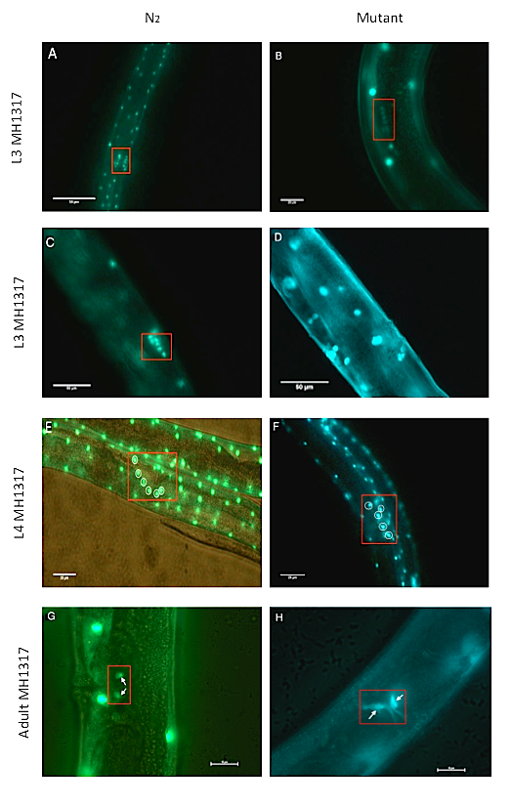
* **Fig. 5 GFP strain MH1317 mark the gene *egl-13* and *Unc-119 (+)* to localise uterus pi cell lineage and body wall muscle in c. elegans. A) The N2 *c. elegans* with MH1317 GFP stain at L3 stage, there are 12 cells can clear be labelled by GFP, which maybe the 12 grand-progeny cells divided from 3 ventral uterus (VU) precursor cells (40X). B) Mutant L3 *c. elegans* with GFP stain that 6 cells can be blurry seen, which can be the uterus pi cell in the worm (60X). C) In the N2 L3 *c.elegans*, it shows 6 cells brightly marked by GFP in on side of the worm, and are the 12 grand-progeny cells. D) Only body wall muscle cells are labelled in the mutant L3 *c. elegans*, no other cells are apparently labelled. E) 6 cells are marked by GFP in the N2 L4 *c. elegans*, and the 6 cells are around vulva, which are the uterus pi cells. F) 5 uterus pi cells can be distinguished with body wall muscle in mutant L4 *c. elegans*, but cells sit irregularly around vulva. G) Two uv1 cells marked by GFP in the adult *c.elegans*. H) In adult mutant *c. elegans*, 2 uv1 cells marked by GFP clearly, and bvifurcated shape of the line presented above the vulva.**
* 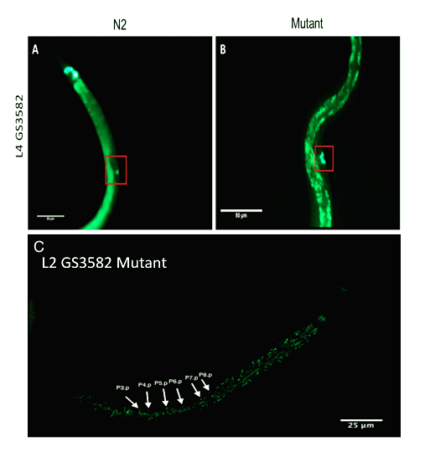
* **Fig. 6 GS3582 is the GFP stain that show *egl-17::cfp* in the vulva precursor cells (VPCs) in *c. elegans*. A) In N2 L4 *c. elegans,* that cells are labelled by GFP dots accumulated at valve development site, B) In L4 mutant *c. elegans*, VPCs marked by GFP. C) The L2 mutant worm, *egl-17::cfp*  are showed in VPCs, the difference expression of *egl::cfp* are shown in three VPCs, P6.p, P7.p and P5.p.**
* **The GS3582 stain mark *egl-17* in the nucleus of VPCs.**
* *Egl-17::cfp::GFP* are in GS3582 stain to label vulva precursor cells (VPCs) at early stage in *c. elegans*. At early L2 mutant c. *elegans*, different expression level of *egl-17::cfp* shown in Fig. 6C, P5.p and P7.p have the highest expression of egl-17::cfp than other cells. Moreover, few cells are GFP expression is shown at vulva site in N2 L4 *c. elegans* (Fig. 6A), which also similar in the mutant L4 *c. elegans* that GFP expression level similar in the few cells clearly and started accumulated around vulva development site (Fig. 6B).
* **Discussion**
* The aim of the project was to investigate the unknown mutant in *c. elegans*. The results provided from egg-laying assay showed that the numbers of eggs laid by mutant worms were significant lower than N2 *c. elegans* did. (Fig.1). According to the observation of eggs that laid by mutant *c. elegans*, most of eggs were at late stages such as lima bean or pretzel, L1 larva laying also observed in egg-laying assay. Thus, the result provided the significant evidence that unknown mutation was possibly the egg-laying defect mutant (Megan et al., 2005; Trent et al., 1983).
* Furthermore, in order to characterise the egg-laying defect mutant, the efficient way is drug test assay. After 90 min administered serotonin and imipramine, the significant result had been shown in Fig. 2 that egg laying defect *c. elegans* were resistant to both pharmological agents. According to Trent et al. (1983), the resistant in both serotonin and imipramine is the category one, that the possibly cause of the mutant in muscle or vulva morphology. The reason is because after administered serotonin and imipramine, there was no eggs laid by mutant stain, which means HSNs were functioning and can release 5-HT normally. Therefore, muscle defect response to signalling or vulva morphology abnormality can be the possibly reason lead to egg-laying defect (Trent et al., 1983; Weinshenker et al., 1995).
* In the meantime, the light touch assay had been performed for mutant *c. elegans*. In the Fig. 4 that most of mutant *c. elegans* were uncoordinated movement after light touching by eyelash compared with N2 *c. elegans*. Therefore, uncoordinated movement might be the pleiotropic mutant phenotype. (Brundage et al., 1996; Pickett and Kornfeld, 2013).
* Moreover, the matting assay had been performed to determine the dominant or recessive of mutant. The N2 males were mating with mutant hermaphrodites and produce F1 heterozygous progeny, and it had been found after F1 worms mature, the egg-laying behaviour were normal, which means the unknown egg-laying defect mutant was the recessive mutant.
* To further characteristic the mutant in *c. elegans*, differential interference contrast (DIC) images were taken to visualise vulva structure and compared between mutant and N2 *c. elegans.* During L4 stage, anchor cell start fuse into utse cell, vulva cell start tubulogenesis and vulva muscle connect with uterus muscle (Sharma-Kishore et al., 1999; Sternberg, 2005). In Fig. 3C&D, it could not find significant difference between N2 and mutant in vulva morphology at early L4 stages, and after measurements of the DIC images in imageJ, the diameters of vulva in mutant & N2, there were no significant difference as well (Fig. 3 F). Thus it might suggest that at early L4, the vulva morphology seems normal.
* Whereas, the DIC images in adult stages shown in Fig. 3A &B that an apparently difference between the vulva in N2 and mutant worms. There was a vulva-protruding situation present in adult mutant worms but not obviously in N2 adult. In addition, the measurements about the diameters of vulva and angles of vulva protrusion were shown in Fig. 3 E&G compared between N2 and mutant worms, the signification difference were existed that mutant worms had larger diameter of vulva and larger angle of vulva protrusion than N2 worms had, which might be the mutant phenotype that vulva morphology defect, but vulva protruding might also can be epistasis defect that was cause by accumulation of eggs or aging. (Brundage et al., 1996; Sharma-Kishore et al., 1999; Trent et al., 1983).
* As DIC images are not sufficient for characteristic the mutant. Green Florence Protein (GFP) assay was performed to provide more evidence to localise the specific cells differentiation in the process of vulva development.
* The three GFP stains were selected in this project, which were MH1317, GS3582 and MT11090. MH1317 stains and GS3582 showed the significant result but not MT11090 stains.
* The GFP stain GS3582 was the GFP marked in *egl-17::cfp*. The expression of *egl-17::cfg* gene is response to EGFR-MAPK pathway in VPCs. The expression of *eg-17::cfp*  gene can be increased by the EGF like inductive signal such as LIN-3 to form graded expression in different VPCs, which means the reporter presents high level expression in P6.p, median level expression in P5.p and P7.p, and lower level in P3.p, P4.p and P8.p (Dutt et al., 2004). It is shown in L2 mutant *c. elegans* (Fig. 2C) that different expression level of *egl-17::cfp* in VPCs, the most brightness cells seem likely are, P7.p and P5.p, and then the intermediate brightness cell is P6.p. It has been mentioned in Dutt et al. (2004) that the absent of anchor cell can allow *egl-17::cfp* expression in all VPCs. However in Fig. 2C, a little few brightness can be seen at other VPCs such as P8.p and P4.p, but it is very difficult to determine the mutant phenotype only depend on one image.
* It has been mentioned in Yoo et al. (2004) that lateral LIN-12 inhibition pathway can activates the expression of different negative regulators of EGFP-MAPK pathway in P5.p and P7.p, such as MAPK phosphatase *lip-1 (14),* which means these negative regulators can counteracted the inductive signal from anchor cell, reduce the promoting expression of *egl-17::cpf* in P5.p and P7.p. Therefore, after activation of LIN-12 pathway (after late L2), in normal c. elegans, only P6.p can still has *egl-17::cpf* expression, but not in P7.p and P5.p. According to Inoue et al. (2005) that gene *egl-17* can keep expressed in P6.p (early L3) until turn off in VulE/VulF (n=8) cells at early L4 stage. In Fig. 6A&B illustrate the image of L4 stage of c. elegans, the N2 L4 might at the early/mid L4 stage, therefore few VulE/VulF cells are expressed *egl-17::cfp::GFP* gene. In mutant L4 *c. elegans* (Fig. 6B), 4 VulE/VulF cells can be seen as GFP, which means, in the mutant stain, the inductive signal from anchor cell is normal, EGFR-MAPK pathway that VPCs accept inductive signal is normal, and lateral LIN-12 (Notch) inhibition pathway activated by P6.p is normal as well. According to the DIC image (Fig. 3C&D), the mutant early L4 worm seemed normal compared with the N2 early L4 worm, which support the result of GS3538 stains. Therefore, as the mutant is normal in 1) anchor cell releasing inductive signal, 2) VPCs’ EGFR-MAPK pathway and 3) P6.p active lateral LIN-12 inhibition pathway, it means during L2-early L4 stage, the development of vulva is normal. Late life stage in *c. elegans* needs to be considered, such as vulva tubulogenesis, anchor cell fusion, vulva muscle connect with uterus muscle (Cinar et al., 2003; Newman et al., 1996; Ranawade et al., 2013).

The description of M1317 stain is *Unc-119 (+) egl-13::GFP,* which localise the uterus pi cell lineage and body wall muscle cells. The result (Fig. 5) shown clearly that in mutant stain presents uterus pi lineage, especially in the mutant adult worm, 2 uv1 cells are apparently marked on one side of *c. elegans* above the vulva. For *egl-13* positive, in the Early-Mid L4 stage worms, the number of GFP positive uterine cells on one side can be between 6.0-6.5, which was shown in Fig. 5E, that 6 uterus pi cells stimulated by anchor cells from 6 grand-progeny ventral uterus (VU) cells (Cinar et al., 2003). Whilst, only 5 uterine cells can be found clearly in Fig. 5F, it might be caused by the mutant in process that anchor cell stimulate VU cells to form pi cells or might because mismatch of taking photos. However, according to the result in GS3582, anchor cell in mutant stain can release inductive signal normally, which is against the above hypothesis. Cinar et al. (2003) mentioned that, the egl-13 mutant might briefly contained two aspects, first was the extra round cell division of pi cell, which means, 4 uv1 cells on each side could been seen; Second was unfused and often very prominent anchor cell nucleus in egl-13 mutant, however in this project results, only 2 uv1 cells are displayed in mutant adult *c. elegans,* which means the connection between uterus and vulva seems normal. In addition, because MH1317 is *kuIs29* transgenic array, anchor cell nucleus is GFP negative, thus the phenotype of anchor cell cannot be determined(Cinar et al., 2003).

* For summarise all the results in mutant stains, the phenotypes in our mutant worms were respectively to 1) egg-laying defect; 2) resistant to serotonin and imipramine, HNS was functioning; 4) recessive; 5) movement uncoordinated; 6) anchor cell release EFP-liked Lin-3 inductive signal is normal; 7) EFPR-MAPK pathway in VPCs is normal; 8) Lateral LIN-12 inhibition pathway is normal; 9) uterus pi cell lineage is normal, which utse and uv1 cells are formed normally; 10) as uv1 cell is normal, the connection with uterus and vulva is normal.
* Thus, anchor cell invasion, vulva tubulogenesis, signal transduction involved in muscle contraction need to be further investigates. For instance, *egl-30* mutant would lead to disrupt the signal cascade involved in muscle contraction. *Egl-30* encodes a heterotrimeric G protein alpha subunit. G protein alpha normally involved in smooth muscle contraction in human, which though the pathway that releases intracellular Ca2+ through IP3 gated channels. Thus, egl-30 mutant in c. elegans can disrupt this signal cascade to defect worms movement, egg-laying behavior and viability. In addition, HSNs are functioning in all egl-30 mutant worms in drug assay, which similar with our result, and egl-30 phenotypes were similar with us that appear uncoordinated muscle contraction in touching assay (Brundage et al., 1996). Therefore, to further determine our mutant type, egl-30 might be suspect mutant in our list.
* Overall, our mutant phenotypes were not sufficient to help us characterize the mutant type in egg laying defect worms. The DIC images of mutant worms at L4 stages were not enough, few GFP images in each stains are not sufficient to provide accurate evident in worm study, and another GFP stains need to be consider, such as *egl-13 (Ku194)::GFP* stain that can mark anchor cell nucleus to investigate the fusion of anchor cell, and *egl-30::GFP* stain which has the similar phenotype with us and investigate the signal transduction consisted in muscle contraction and so on. Therefore, in order to charascterise the mutant type of our *c. elegans*, further study should be performed.
* **Materials and methods**
* **Preparing nematode growth media (NGM) plate**
* In order to preparing NGM plates, about 250ml stock media need to prepare. Melting about 10% 250ml agarose media, after cooling to 60 degree, adding 0.25ml MgSO4 and 0.25ml CaCl2 first and 5.125ml KPO4, chlorophyll from fridge is the last reagent added into media. After mixing, the solution pours into Petri dishes.
* **Seeding NGM plate**
* The fresh NGM plates prepared after 1 day, Escherichia coli OP50 need to be applied to NGM plates. Seeded plats incubated at consistent room temperature (24℃) about 2-3 days
* **Heat shock**
* L4 *c. elegans* were isolated new standard NGM plates and heat-shocked for 5-6 hours in 30℃ incubator to increase the frequency of male production.
* **Egg laying assay**
* N2 and mutant L4 *c. elegans* (N2 n=12, mutant n=12) were picked and cultured on n=24 standard seeded NGM plates in 20 degree incubator, checked and counted eggs about 48 hours (+/– 0.5 hours) later.
* **Drug Test assay**
* N2 and mutant young adult *c. elegans* were picked and placed into 96-well plate with 50 μL of 3 μg/ml serotonin (N2 n=24, mutant n=24), 50 μL of 0.5 μg/ml imipramine (N2 n=24, mutant n=24), and 50μL of M9 buffer

|  |  |  |  |
| --- | --- | --- | --- |
| GFP line | Description | Gene | GFP expressed |
| MT11090 | nIs106 [lin-11::GFP + lin-15(+)] X. Egl, Him. | Lin-11 | In vulva (especially P5.p, P7.p) |
| MH1317 | kuIs29 [unc-119(+) egl-13::GFP(pWH17)] V | Unc-119(+) egl-13 | -In body wall muscles  -Uterine pi lineage |
| GS3582 | arIs92[egl-17p::NLS-CFP-LacZ + unc-4(+) + ttx-3::GFP] | Egl-17 | In the nucleus for each of the Pn.p cells |

* (N2 n=24, mutant n=24) respectively per well and left for incubation at 20℃. After 90 min counted the number of eggs laid.
* **Light touching assay**
* Single blind light touch assay on mutant and N2 *c. elegans* (n=30 for each group). Picked n=3 young adult hermaphrodites per NGM plates. Use the eyebrow hair attached to a pipetted tip and touched just below the pharyngeal bulb and coordination behaviour observed, counted with 1=coordinated and 0=uncoordinated.
* DIC
* 4% agarose was dropped onto slides for preparing, and a drop of tetramisole was added onto the slide before worms picked on the slide. DIC image for N2 and mutant worms were taken under 40X and 60X magnification on DIC microscope (Nikon Eclipse 80i). Then using imageJ to measure vulva diameter and angle of vulva protrusion.
* **Green fluorescence protein (GFP) strains**

Three GFP strains (table 1) were chosen to help to characterise mutant in c. elegans, which are showed in supplementary material. After several crossing and self progeny, GFP F2 hermaphrodites produced, picked worms under dissecting GFP microscope (Olympus CKX41) on the prepared slides, and took photos under 40X, 60X and 100X magnification on fluorescent microscope.

**Table 1. The description of GFP stains that were used in this project.**

* **Data Analysis**
* All data were mean=±SEM, and the statistic analysis had been performed in GraphPad Prism 6, by using unpaired Student’s t-test, Mann Whitney’s test, Two-way ANOVA assuming significant difference at p<0.05 for statistical comparisons between different groups. All the measurement in DIC images had been measured for 3 times by using ImageJ, and analgised in GraphPad Prism 6.

**Acknowledgement**

The author is grateful to Dr Ethan Scott, Dr Massimo Hilliard, Dr Sean Millard and Bruno van Swinderen for all the helps in this project and grateful to the entire principle of biomedical science lab for suggestion and helps.

Reference:

Alkema, M.J., Hunter-Ensor, M., Ringstad, N., and Horvitz, H.R. (2005). Tyramine Functions Independently of Octopamine in the Caenorhabditis elegans Nervous System. Neuron *46*, 247-260.

Bettinger, J.C., Euling, S., and Rougvie, A.E. (1997). The terminal differentiation factor LIN-29 is required for proper vulval morphogenesis and egg laying in Caenorhabditis elegans. Development *124*, 4333-4342.

Blaxter, M. (2011). Nematodes: the worm and its relatives. PLoS Biol *9*, e1001050.

Brundage, L., Avery, L., Katz, A., Kim, U.J., Mendel, J.E., Sternberg, P.W., and Simon, M.I. (1996). Mutations in a C. elegans Gqalpha gene disrupt movement, egg laying, and viability. Neuron *16*, 999-1009.

Chalfie, M., Tu, Y., Euskirchen, G., Ward, W.W., and Prasher, D.C. (1994). Green Fluorescent Protein as a Marker for Gene Expression. Science *263*, 802-805.

Cinar, H.N., Richards, K.L., Oommen, K.S., and Newman, A.P. (2003). The EGL-13 SOX domain transcription factor affects the uterine pi cell lineages in Caenorhabditis elegans. Genetics *165*, 1623-1628.

Dutt, A., Canevascini, S., Froehli-Hoier, E., and Hajnal, A. (2004). EGF signal propagation during C. elegans vulval development mediated by ROM-1 rhomboid. PLoS Biol *2*, e334.

Fire, A. (1986). INTEGRATIVE TRANSFORMATION OF CAENORHABDITIS-ELEGANS. EMBO J *5*, 2673-2680.

Inoue, T., Wang, M., Ririe, T.O., Fernandes, J.S., Sternberg, P.W., and Davidson, E.H. (2005). Transcriptional Network Underlying Caenorhabditis elegans Vulval Development. Proc Natl Acad Sci U S A *102*, 4972-4977.

Megan, P., Palm, M., Schafer William, R., Geng, W., and Cosman, P. (2005). Caenorhabditis elegans Egg-Laying Detection and Behavior Study Using Image Analysis. EURASIP journal on advances in signal processing *2005*, 968352.

Newman, A.P., White, J.G., and Sternberg, P.W. (1996). Morphogenesis of the C. elegans hermaphrodite uterus. Development *122*, 3617-3626.

Pazdernik, N., and Schedl, T. (2013). Introduction to germ cell development in Caenorhabditis elegans. Adv Exp Med Biol *757*, 1-16.

Pickett, C.L., and Kornfeld, K. (2013). Age-related degeneration of the egg-laying system promotes matricidal hatching in Caenorhabditis elegans. Aging Cell *12*, 544-553.

Ranawade, A.V., Cumbo, P., and Gupta, B.P. (2013). Caenorhabditis elegans Histone Deacetylase hda-1 Is Required for Morphogenesis of the Vulva and LIN-12/Notch-Mediated Specification of Uterine Cell Fates. G3-Genes Genomes Genetics *3*, 1363-1374.

Schafer, W.F. (2006). Genetics of egg-laying in worms. Annu Rev Genet *40*, 487-509.

Sharma-Kishore, R., White, J.G., Southgate, E., and Podbilewicz, B. (1999). Formation of the vulva in Caenorhabditis elegans: a paradigm for organogenesis. Development *126*, 691-699.

Sternberg, P.W. (2005). Vulval development (Pasadena).

Sulston, J.E., and Horvitz, H.R. (1977). Post-embryonic cell lineages of the nematode, Caenorhabditis elegans. Dev Biol *56*, 110-156.

Sulston, J.E., Schierenberg, E., White, J.G., and Thomson, J.N. (1983). The embryonic cell lineage of the nematode Caenorhabditis elegans. Dev Biol *100*, 64-119.

Trent, C., Tsuing, N., and Horvitz, H.R. (1983). Egg-laying defective mutants of the nematode Caenorhabditis elegans. Genetics *104*, 619-647.

Weinshenker, D., Garriga, G., and Thomas, J.H. (1995). Genetic and pharmacological analysis of neurotransmitters controlling egg laying in C. elegans. J Neurosci *15*, 6975-6985.

Yoo, A.S., Bais, C., and Greenwald, I. (2004). Crosstalk between the EGFR and LIN-12/Notch pathways in C. elegans vulval development. Science *303*, 663-666.