The novel treatment of SGLT2 inhibition works on type 2 diabetes mellitus

(**Please only read abstract, introduction and discussion.)**

**Abstract**

Sodium-glucose co-transporters (SGLTs) inhibition is the novel treatment for diabetes, which is more efficient than regular treatments such as metformin etc. The study was to determine the effects of SGLT2 inhibition (using EMPA as inhibitor) on glucose tolerance and on diabetic nephropathy, compared with treatment metformin and co-therapy (metformin + EMPA combination treatment). After 20 weeks of treatment for 6 mice groups, the results of this study were collected for glomerular filtration rate (GFR), oral glucose tolerance test (OGTT), western blot, and Periodic Acid Schiff’s (PAS) staining. The results were analysed by one-way ANOVA in Tukey’s multiple comparison tests, which had been concluded that co-administration of metformin and EMPA was more efficient on treating hyperglycemia than mono-therapy of EMPA. EMPA treating on diabetic mice might help attenuate kidney imprisonment, glomerular basement membrane thickening and also a hyperglycemia independent increase in GFR.

**Introduction**

Type 2 diabetes mellitus (T2DM) is becoming the fastest growing disease worldwide [20]. Diabetes has been estimated to affect 11 million people in Australia with 9 million patients affected by Type 2 diabetes [14]. Diabetes is characterised by a combination of deficiency in insulin secretion and sensitivity. Insulin helps cells uptake of glucose and aid in glucose metabolism. The distinguishing features of T2DM are progressive pancreatic β cell failure and non-insulin dependent mellitus, which different with Type 1 diabetes mellitus that is associated with the immune system and insulin dependency [18]. Insulin resistance is the most common feature in a T2DM patient, which is defined as the loss of cellular signalling in response to insulin. Insulin resistance is mostly present in skeletal muscle, liver and adipose tissue [6]. There are several complications in diabetes that might arise due to glucotoxicity, including microvascular diseases such as neuropathy, nephropathy and retinopathy, and macrovascular disease such as cardiovascular, cerebral and peripheral vascular disease [4]. The majority complication in diabetes is nephropathy and would cause the high morality of the diabetes, which means it needs to be considered along with the diabetic treatment.

Diabetic nephropathy is the leading result in end of stage renal disease (ESRD) and chronic kidney disease [5][15]. Increase hemodynamic results in the glomerular hyperperfusion and hypertension, which lead to hyperfiltration of the kidney causing an increase in the leakage of albumin from the glomerular capillaries. This alters kidney structure such as thickening of glomerular and tubular basement membranes and causes podocytes injury and loss [2][10]. Therefore an increase in albumin in urine excretion and kidney injury protein expression such as (KIM)-1 would be the biomarker of diabetic nephropathy [16][19]. Glomerular filtration rate (GFR) is a measure of kidney filtration function or kidney function, it happens when blood flow filtrated in the glomerular space. Reduction of glomerular filtration rate (GFR) is another biomarker of diabetic nephropathy, which is indicative of kidney failure along with arterial hypertension and increased cardiovascular risk [17]. Therefore some diabetic treatments need to be considered for treating diabetic nephropathy at same time.

Therapies for T2DM focus on three ways to improve glycemic control. 1) Increasing insulin section (insulin secretagogues). 2) Increasing insulin action (insulin sensitizers). 3) Decreasing insulin need (inhibitors of glucose reabsorption)[20].

Currently, metformin, sulphonylureas and exogenous insulin therapy are the most common treatment for T2DM. Metformin is used in this study, which is the most frequent first line of treatment of T2DM. Metformin suppresses gluconeogenesis (generation of glucose) in the liver to decrease hyperglycemia. However, metformin isn’t effective during the later stages of diabetes as residual β-cell function decreases leading which is important in the absorption of metformin. Therefore, other therapies have been developed for the control of blood glucose, such as SGLTs inhibition.

Sodium-glucose co-transporters (SGLTs) allow for re-absorption of glucose in the kidney. There are two main subtypes of SGLTs, SGLT1 and SGLT2.

SGLT1 is mediate glucose reabsorption in intestine and SGLT2 is mediate in kidney. SGLT2 is a high capacity transporter for the reabsorption of glucose found in the apical side of proximal convoluted tubule cells (PTCs) and is coupled with the glucose transporter 2 (GLUT2) that is located on the baso-lateral side of the cell. Na+ and glucose are co-transported from lumen side to blood vessel via SGLT2 (**Figure 1**). SGLT2 is responsible for about 90% of the glucose reabsorption into the blood in the kidney. Thus inhibiting the reabsorption of glucose is a novel therapeutic strategy to reduce the plasma glucose level. The mechanism of SGLT2 inhibition is independent of insulin secretion and there is reduced risk for hypoglycaemia compared to insulin dependent therapies making it an attractive therapeutic option.

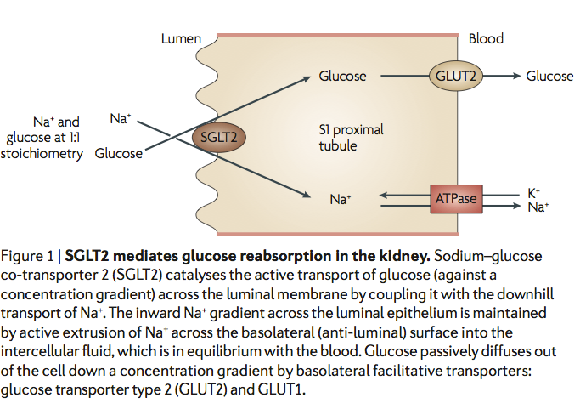

**Figure 1. SGLT2 mediates glucose reabsorption in the kidney**

There are a few SGLT2 inhibitors that are usually used in Australia, including Dapagliflozin, Canagliflozin and Empagliflozin (EMPA) [21]. Empagliflozin (EMPA), a potent oral SGLT2 inhibitor developed by Boehringer-Ingelheim, was used in the study [15]. EMPA reduces the blood glucose level, by inhibiting the reabsorption of glucose back into the blood stream leading to a reduction in renal inflammation and fibronection. This suggests that EMPA might protect the PTCs from glycotoxicity [15].

However, there are some adverse effects need to be considered. The therapy inhibits glucose reabsorption thus increasing glucose excretion in the urine, which may result in glycosuria with deleterious effects on kidney function and may cause dehydration in the long term [4]. Furthermore, since inhibition glucose/ Na+ reabsorption back to the blood vessel, which increase the Na+ delivery to the macula densa but not in blood vessel, which causes a drop in GFR and constricts the afferent arteriole [10][22]. While SGLT2 inhibitors have been found as effective agents for reducing blood glucose in animal models and humans without diabetic nephropathy, but the effects on the models with diabetic nephropathy have not been fully determined [10][15].

The aims of this study were to determine how EMPA affects blood glucose levels and renal function that is a risk factor of nephropathy and renal imprisonment in a T2DM mouse model. This was compared with a control group of untreated mice (vehicle) and another group of mice, which were administered with the commonly used anti-diabetic therapy, metformin. It was hypothesized that EMPA would reduce glucose reabsorption and increase glucose excretion in urine, but increase kidney protein expression such as kidney injury molecule (KIM)-1 expression, which may increase the risk of the kidney disease.

**Method**

All experiments were approved by The University of Queensland Animal Ethics Committee (#462/12). Db/m mice and db/db mice were bred and housed in plastic cages with stainless steel wire lids in an environmentally controlled room at temperature 20-22°C, relative humidity 45-55%, 12h light/dark cycle (PACE Facility, The University of Queensland). All mice had access to standard mice chow. 6 groups mice were tested in this study, db/m control, db/m EMPA, db/db control, db/db EMPA, db/db metformin, db/db metformin+EMPA cotherapy, and each group contained 5 mice. A pre treatment blood sample was taken by tail tipping. Mice received oral treatment by daily gavage each afternoon from 10-20 weeks of age (EMPA: 10mg/kg/day, metformin: 250mg/kg/day, cotherapy: dose as per single therapy).

Metabolic cage measurements

Mice were weighed and placed individually in metabolic cages for 24hr at 12-13 weeks and 16-17 weeks of age to measure the food intake, water intake and urine volume. Before 24hr collection at both ages, mice were trained with a 3hr session and two days later, a 6hr session to minimise stress and associated behavioral changes. Measurements began 2 days following the acclimatization period. Food and water were weighed and mice were allowed *ad libitum* access throughout the experiment. Urine was collected in removable clean containers. After 24hr, food and water intake, as well as urine volume were recorded. Blood was collected by tail tipping, centrifuged at 3,000 rpm for 10 minutes and plasma stored in eppendorf tubes at -20°C for next biochemical analysis with urine samples.

Glomerular Filtration Rate (GFR)

The glomerular filtration rate was estimated using a miniaturized device placed on the mice back for measurement of transcutaneous decay of intravenously injected FITC-labeled sinsitrin. Measurements were performed for about 1hr and software was used to determine the half-life and calculate GFR as per manufacturers instructions [18] (**Figure 2**).

Oral Glucose Tolerance Test (OGTT)

Mice were fasted for 6 hours before an oral glucose tolerance test (OGTT). Mice were weighed to determine the volume of glucose solution to gavage. Glucose solution (2g/kg; 50% w/v glucose solution, Phebra, Lane Cove, Australia) was immediately administered directly into the stomach of mice via a 1ml syringe attached to a 20 gauge 38mm long flexible plastic gavage needle with a 1.6mm diameter ball end (Walker Scientific, add city, Western Australia, Australia) in restrained mice [1]. Blood glucose was determined prior to glucose gavage, and at 5, 15, 30, 60 and 120 min post-gavage by tail tipping. Mice were unrestrained during the test and housed in their usual group boxes apart from being restrained during the single gavage and during blood collection.

Cull

Cull was performed on all mice. Blood glucose was determined by tail tipping, and blood sample collected into 1.5ml eppendorf tube with EDTA. Mice were injected with sodium pentobarbital (intraperitoneal; 32.5mg/ml diluted stock; multiply mouse weight by 3.08 for 100mg/kg). Reflexes were checked and once the mouse was under, a midline incision was performed. Urine was collected using 1ml syringe with 27gauge needle into bladder. Urine was stored in labeled 1.5ml eppendorf tube and frozen for later tests. The left and right kidneys were excised and weighed separately,, sliced into coronal sections and a piece fixed in 10% NBF solution for later processing. Kidney cortex was sliced away and immediately snap frozen in liquid nitrogen and placed in -80°C for later Western blot test.

Plasma membrane protein extraction, BCA Protein Assay and Western Blot

A plasma membrane protein extraction kit was used to separate cytosol and plasma membrane protein of frozen kidney cortical tissue (Biovision, Catalog #K268-50). Briefly, tissues were lysed in Homogenization Buffer and Protease Inhibitor Cocktail (10ul to 5ml buffer) and centrifuged at 700xg for 10 minutes at 4°C. The supernatant was centrifuged at 10000xg for 30 minutes at 4°C. The supernatant was the cytosol fraction. To purify plasma membrane protein, a lower phase and upper phase solution were added to the pellet and kit instructions followed. After the protein was collected, a BCA Protein Assay was performed to determine the protein concentration. 50ug of protein was mixed with Laemmli buffer/2-ME containing mercaptoethanol and heated at 95°C for 5 minutes to denature the protein. Sample and protein standard were then loaded into Bi-rad pre-cast 10% Tris-HCl gels, filled with running buffer from 10X bio-rad stock and then run the gels at 200V for 30minutes. Gels were then transferred onto PVDF membranes in transfer buffer that contained 1x Tris/Glycine (Bio-rad Cat# 162-0260) at 350mA for 1 hr. Membranes were blocked with 5% skim milk for 1hr gently rolling at room temperature. 1M TBS-T (Tris Buffered Saline with 0.1% Tween) was used to wash the membrane for 10 minutes. Membrane were incubated overnight at 4°C with the following primary antibodies: GLUT4 rabbit anti–mouse used at 1:300 (Abcam), SGLT2 rabbit anti–mouse used at 1:400 (Abcam), Kidney Injury Molecule-1 (KIM-1) rabbit anti-mouse used at 1:1000 (Abcam) and loading control β-actin rabbit anti-mouse used at 1:2000 (Sigma), diluted in 1M TBS-T containing 0.05% skim milk. Membranes were washed with 1M TBS-T 3 x 10 minutes and incubated with IR-secondary antibody for 1 hr at room temperature. Membranes were washed in 1M TBS-T 3 x 10 minutes and visualized using the Li-cor infrared (IR) fluorescent detection.

Periodic Acid Schiff’s Staining

Periodic Acid Schiff’s stain was used to assess the degree of kidney damage. PAS staining gave the pink image after performing, and the blue dots indicated nuclei and pink was the cytosolic fibers. Slides were dewaxed in xylene first and then rehydrated in 100% EtOH, 95% EtOH, 70% EtOH and distilled water. Slides were placed in 1% periodic acid for 5 minutes, washed briefly, and placed into Schiff’s reagent for 15 minutes. Slides were washed and placed in Mayer’s Haematoxylin for 5 minutes, then washed and placed in Scott’s tap water briefly. Finally, slide were dehydrated from 70%, 95% to 100% EtOH. They were then cleared using xylene and coverslipped using DPX. Sections were observation was a light microscope (Nikon Brightfield) and representative images taken at x20 magnification.

Statistical Analyses

Results were given as mean ± SEM (standard error of the mean) as indicated. For comparisons, one-way ANOVA in Tukey’s multiple comparison tests. Statistic and data analysis was performed using GraphPadPrism Software Version 6c (GraphPad Software, Inc.).

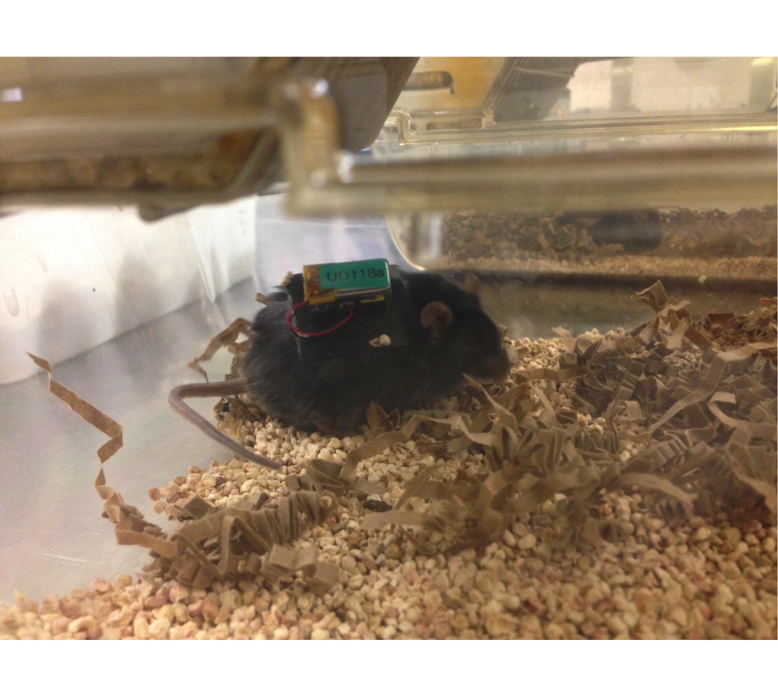

Figure 2. Mice with miniaturized device to detect the transcutaneous decay of intravenously injected FITC-labeled sinsitrin.

**Results**

Metabolic caging

-Water intake

Water intake during metabolic caging 1 is presented in **Figure 3**. There were no significant different between all 6 groups (P>0.05). In metabolic caging 2, the mean values for water intake were shown in **Figure 4**.All db/m mice drank less water than db/db mice (p<0.05). Empagliflozin treatment in db/db mice resulted in a significant reduction in water intake compared with db/db Control (p<0.05).

-Food intake

The mean values of food intake in metabolic caging 1 are presented in **Figure 5**. There were no differences between each group (p>0.05). **Figure 6** shows the mean value of food consumption during metabolic caging 2. There were no significant differences between each group (p>0.05).

-Urine volume

**Figure 7** displays the results of urine volume recorded during metabolic caging 1 and it shows that the healthy mice (db/m) had much lower urine volume than diabetic mice (db/db) (p<0.05), and there was a trend that the drug treatments of diabetic mice decreased the urine excretion volume compared with db/db control. Furthermore, in **Figure 8**, it shows the urine volume collected in metabolic caging 2 was higher in all diabetic mice groups than healthy mice groups (p<0.0001).

**Table 1. Mice number in metabolic cages for each group.**

|  |  |  |  |  |  |  |
| --- | --- | --- | --- | --- | --- | --- |
|  | db/m water control | db/m EMPA | db/db hydroxyl control | db/db EMPA | db/db metformin | db/db metformin+EMPA cotherapy |
| Metabolic cage 1 | N=4 | N=4 | N=5 | N=5 | N=5 | N=5 |
| Metabolic cage 2 | N=5 | N=5 | N=5 | N=5 | N=5 | N=5 |



**Figure 3. H2O intake 1**. H2O intake recorded in metabolic caging at 12-13 weeks of age (n=4 for db/m control and db/m EMPA, n=5 for rest of the groups). Data presented mean=±SEM. No significant differences between each group (p>0.05).



**Figure 4. H2O intake 2**. H2O intake recorded in metabolic caging at 16-17 weeks of age (n=4 for db/m control, n=5 for rest of the groups). Data presented mean=±SEM, one star: p<0.05, a: p<0.05 vs db/m groups.



**Figure 5. Food intake 1**. Food intake during in metabolic caging at 12-13 weeks of age. (n=4 for db/m control and db/m EMPA, n=5 for rest of the groups). Data presented mean=±SEM. No significant differences between each group (p>0.05).



**Figure 6. Food intake 2**. Food intake during metabolic caging 2 at 16-17 weeks of age (n=4 for db/m control and n=5 for rest of the groups). Data presented mean=±SEM. No significant differences between each group (p>0.05).



**Figure 7. Urine volume 1**. Urine volume recorded during metabolic caging 1 at 12-13 weeks of age (n=4 for db/m control and db/m EMPA, n=5 for rest of the groups). Data presented mean=±SEM, a: p<0.05 vs db/m groups.



**Figure 8. Urine volume 2.** Urine volume collected during metabolic caging 2 at 16-17 weeks of age (n=4 for db/m control and n=5 for rest of the groups). Data presented mean=±SEM, a: p<0.5 vs db/m groups.

Body Weight and Fasting Glucose

Diabetic mice had a significant increase in body weight compared with healthy mice at all ages (p<0.0001, **Figure 9A-C**). However, treatments did not change the body weight in db/db mice.

In Figure **10A-C**, the fasting blood glucose of mice at week 11, week 15 and week 20 of age is presented. The db/db mice groups had significant high fasting glucose value than db/m mice groups. The treatment of EMPA in db/db mice was remarkably efficient at reducing blood glucose levels at all ages compared with db/db control (p<0.01). In the meantime, co-therapy was the second efficient treatment that decreased the glucose level (p<0.01 vs. db/db control).



B

A

C



**Figure 9. Body weight of mice.** (A) Mice at age of 10 weeks (B) 14 weeks (C) 17 weeks (n=5 for each group). Data presented mean=±SEM, a: p<0.05 vs db/m groups.

A

B





C

**Figure 10 A-C. Fasting blood glucose of mice.** (A) Mice at age of 11 weeks (B) 15 weeks, (C) 20 weeks. (n=5 per group) Data presented mean=±SEM, a: p<0.05 vs db/m groups, one star: p<0.05, two stars: p<0.001, three stars: p<0.0001, four stars: p<0.00001.

Glomerular Filtration Rate (GFR)

The glomerular filtration rate (GFR) is presented in **Figure 11**. It was clear to see that db/db control group had the highest value of GFR (mean=1383ul/min/100g) than db/m mice and the three therapies in db/db mice (EMPA 1016 ul/min/100g, metformin 835.3ul/min/100g, co-therapy 948.2ul/min/100g) but the only significant difference by one-way ANOVA was between db/db control and db/db metformin (p<0.05)



**Figure 11. Glomerular Filtration Rate (GFR).** (n=4 for db/m control and n=5 for rest of the groups). Data presented mean=±SEM, one star: p<0.05..

Oral Glucose Tolerance Test (OGTT)

Oral glucose tolerance test (OGTT) was presented in **Figure 12**. At 0 minutes, prior to glucose gavage, db/m mice had lower fasting blood glucose compared with db/db mice (p<0.05) expect the db/db co-therapy group. After gavage of glucose solution, all db/m mice had significantly lower blood glucose compared to db/db mice at all time points (p<0.05). Moreover, at 0 minutes, db/db EMPA and db/db co-therapy groups had lower blood glucose compared to db/db control (p<0.05). At 5 minutes after gavage, only db/db co-therapy had reduced blood glucose compared to db/db control group (p<0.05). Furthermore, at 120 minutes, the only significant difference to db/db control group was db/db co-therapy with lower blood glucose (p<0.05).

**Figure 13** indicates the area under glucose curve (AUGC) (n=5 per group). Diabetic mice had higher AUGC than healthy mice (p<0.05). The therapies did not have a significant effect on mice for AUGC (p>0.05).



**Figure 12. Oral glucose tolerance test.** (n=5 for each group). Data presented mean=±SEM, a: p<0.05 vs db/db control, b: p<0.05 vs all db/db groups c: p<0.05 vs db/db control, d: p<0.05 vs db/db control.



**Figure 13. Area under glucose curve (AUGC).** (n=5 for each group). Data presented mean=±SEM, a: p<0.001 vs db/m groups

Cull Data

There were a total of 24 mice culled in this study. **Table 2** below shows the mean body weight, blood glucose, weight of left kidney, right kidney and total kidney, and the total kidney to body weight ratio (×1000). db/m mice had lower body weight and blood glucose levels than db/db control mice (p<0.05). Furthermore, the body weights of treatment groups were higher than control groups (p<0.05). Moreover, db/db EMPA and db/db co-therapy had lowest ratio of kidney and body weight compare to db/m groups and db/db control (p<0.05).

**Table 2. Body and organ weights and blood glucose levels at cull.** (n=4-5/group) Data presented mean±SEM. a: p<0.05 vs db/db groups. b : p<0.001 vs db/db groups. c: p<0.05 vs db/m control. d: p<0.05 vs db/m EMPA. e: p<0.05 vs db/db control.

|  |  |  |  |  |  |  |
| --- | --- | --- | --- | --- | --- | --- |
| Mouse # | Db/m control | Db/m EMPA | Db/db control | Db/db EMPA | Db/db metformin | Db/db EMPA+met |
| Body weight (g) | 27.50± 0.42a | 28.76 ±0.41a | 37.90±  3.63 | 46.20 ±2.05 | 38.70 ±3.89 | 48.14 ±0.94 |
| Blood glucose | 9.13 ±0.19b | 9.52 ±0.32b | 33.30 | 22.70 ±6.81 | 32.74 ±0.56 | 22.14 ±3.27 |
| Left kidney (g) | 0.17 ±0.01 | 0.17 | 0.18 | 0.18 ±0.01 | 0.19 ±0.02 | 0.19 ±0.01 |
| Right kidney (g) | 0.17 ±0.01 | 0.18 ±0.01 | 0.21 ±0.01 | 0.20 ±0.01 | 0.19 ±0.05 | 0.21 |
| Total kidney (g) | 0.34 ±0.02 | 0.34 ±0.01 | 0.39 ±0.01 | 0.38 ±0.02 | 0.39 ±0.04 | 0.40 ±0.01 |
| Total kidney/Body weight (×1000) | 12.29± 0.85 | 11.92±0.26 | 10.46±0.95 | 8.23±0.25cde | 10.10±0.79 | 8.31  ±0.17cde |

Albumin standard assay

The albumin assay is presented in **Figure 14**. There was a significant increase in albumin excretion rate in all db/db mice compared to db/m mice at both ages during metabolic caging (p<0.05), but no significant effect of treatment.



B

A

**Figure 14. A & B Albumin excretion rate**. Age of A) 12-13 weeks and B) 16-17 weeks. Data presented mean±SEM, (A: n=1 db/m control, n=4 db/m EMPA, db/db EMPA, n=5 rest of the groups; B: all groups n=5), a: p<0.05 vs db/m mice.

Western blot

The results of Western blot are shown below. **Figure 15** shows GLUT4 protein expression. The bands were not very clear, but it showed that bands for the membrane fraction were all around 50KDa (expected size of GLUT4), and metformin, co-therapy treatment for db/db mice had darker bands than other groups. Additionally, cytosol protein did not give any clear results. **Figure 16** gave the results of KIM-1. It indicates that all bands are about 50KDa, and db/m EMPA and db/db control had greater protein expression.

The results of SGLT2 are shown in **Figure 17**, there were two bands for each groups, and all around 50 KDa. In the figure, it showed membrane bands in metformin group and co-therapy group had higher values of protein than other groups, but they were loaded onto a different gel so it is difficult to compare accurately at this stage. Moreover, the cytosol bands in all the groups were not clear.

db/m cont db/m EMPA db/db cont db/db EMPA L CMC M C M C M

db/db MET db/db CO L c m c m



75kDa

50kDa

**Figure 15. Glucose transporter 4 (GLUT4).** L=protein ladder, C=cytosol fraction, m=membrane fraction.

1 2 3 4 5 6 7



KIM-1

75kDa

Β-actin



50kDa

**Figure 16. Kidney injury molecule (KIM)-1 expression in cytosol fractions.**  Lane 1=ladder, lane 2=db/m control, lane 3=db/m EMPA, lane 4= db/db control, land 5= db/db EMPA, lane 6= db/db metformin, lane 7=db/db EMPA+metformin.

db/db MET db/db CO L C M C M

db/m cont db/m EMPA db/db cont db/db EMPA L C M C M C M C M





**Figure 17. SGLT2**. L=protein ladder, C=cytosol fraction, m=membrane fraction.

Kidney histology

PAS of fixed kidney tissue is presented below (**Figure 18 a, b, c, d**). The blue dots indicated the nucleus and the pink indicates collagen fibre. In db/db control, there was greater degree of glomerular fibrosis than db/m groups, determined by more intense pink staining and basement membrane thickening. Moreover, there was evidence for tubular damage in these mice. Empagliflozin treatment in the db/db group improved the degree of kidney damage.

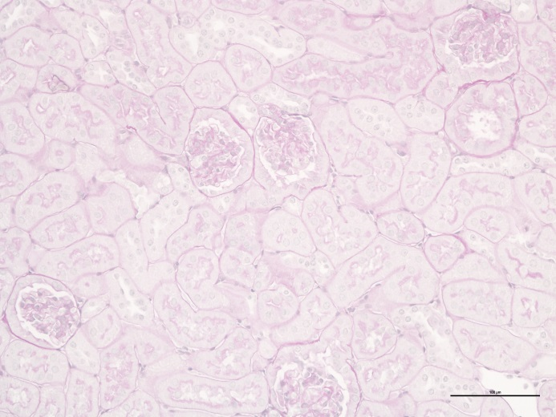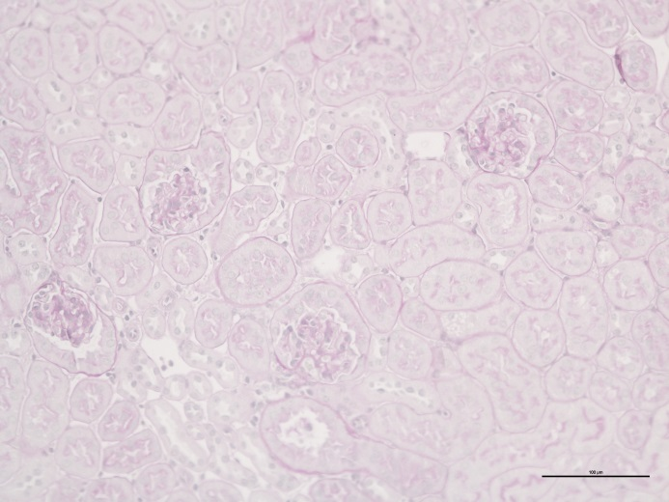13-142 db/m control (a) 13-165 db/m empa (b)

13-171 dbdb control (c) 13-175 dbdb empa (d)

Scale = 100µm

**Figure 18 a-d. PAS staining of each group in scale 100μm.** Arrow indicated glomerular basement membrane thickening, circle indicates tubular damage.

**Discussion**

The aims of this study were to determine the effects of SGLT2 inhibition on renal function in T2DM mice and also on glucose transporter expression in kidney. The findings showed that the diabetic mice that were treated with EMPA were observed to have a thinner glomerular basement membrane compared to that of the diabetic control group based on the PAS staining result. Furthermore, KIM-1 in western blot results did not have high expression in the treatment group compared to the control, which means it might help to protect the kidney cell.

As expected, the fasting glucose levels were reduced after EMPA treatment and co-therapy (EMPA + metformin) in diabetic mice with no difference between the two treatments, meaning it is unclear which treatment was more efficient.

However, according to oral glucose tolerance test (OGTT), co-therapy for diabetic mice had the highest efficacy for glucose clearance in blood. The co-administration of metformin and EMPA enhances the effectiveness of the treatment, which elicits the biological or medicinal response in a tissue system, animal or human [13]. Metformin mono-therapy did not give any significant effect on treating hyperglycemia in the weekly fasting blood glucose test or oral glucose tolerance test. Although metformin works in the liver to inhibit gluconeogenesis in order to treat hyperglycemia and remit T2DM, most patients need further treatments to maintain normal or near-normal glycaemia [12]. Therefore, co-administration was the most efficient treatment for reducing blood glucose than mono-therapies.

There was a trend for the diabetic control group to hyperfilter (increased GFR) compared to healthy mice, but was not significant. All the treatments for diabetic mice reduced GFR compared with the diabetic control, but the only significant difference was in the metformin group. The reasons for hyperfiltration in diabetic mice are caused by increased glucose and sodium reabsorption into PTCs. This will result in a reduction in Na+ delivery to the macula densa, which will reduce Na-Cl-K concentration at macula densa, and through tubuloglomerular feedback will decrease the hydrostatic pressure in glomerular space and increase the GFR. Therefore the reduction of GFR after treatments (EMPA group and co-therapy group) might be because a reduction of glucose and Na+ reabsorption leading to an increase in Na+ delivery to macula densa and causes a drop inGFR. The results mean that after treatment, GFR dropped and restored kidney function, which was disrupted by T2DM.

In western blot result, the protein expression of kidney injury molecule (KIM) -1 was greater in healthy EMPA and diabetic control groups, which suggested a presence of kidney injury. As hyper-glycemia is known to damage kidney cells and thicken the glomerular basement membrane (nephropathy), which was observed from the PAS stains results [9], it might explain why KIM-1 protein expression was raised in diabetic control group.

After treating diabetic mice with EMPA, the KIM-1 protein expression became normal, which suggested EMPA might protect the kidney from hyper-glycemia and reduce the risk of nephropathy. On the other hand, EMPA treatment of the healthy mice groups showed that KIM-1 protein expression increased because it disturbed normal glucose reabsorption and more sodium might be delivered to macula densa to induce afferent arteriole contraction, leading to reduced blood flow into the kidney causing the injury of kidney [10]. Furthermore, glucosuria is a potential risk for urinary tract and genital infection, which may have worsen kidney injury in healthy EMPA group [3][4].

In order to test kidney pathology, PAS staining was performed. The representative images showed that the healthy control mouse had a thinner glomerular basement membrane compared with diabetic control, which was supported by the KIM-1 Western blot result. Also, more tubular damage existed in diabetic control than diabetic EMPA, which means EMPA treatment in diabetic mice may help ease the kidney damage induced by hyperglycemia and might protect the glomeruli and tubules. The probable explanation was that EMPA helped to lower hyperglycemia, which decreased the GFR to normal level after treatment. This prevented a high perfusion pressure induced by hyperglycemia through the kidney. In addition, it indicates that EMPA attenuated the glomerular size, molecular markers of kidney growth (KIM-1), and reduced inflammation [22]; therefore EMPA might help protect the kidney cells in diabetic mice.

**Conclusion**

In conclusion, SGLT2 inhibition by EMPA could decrease blood glucose levels in diabetic mice, which was the consequence of decreasing renal glucose reabsorption. Co-administration of metformin and EMPA was most effective compared to the mono-therapy of EMPA. Moreover, treating with EMPA in diabetic mice might decease the nephropathy via attenuating kidney impairment, glomerular basement membrane thickening and inflammation. Thus the hypothesis that kidney injury will increase from the administration of EMPA was rejected.

**Reference**

Andrikopolous, Evaluating the glucose tolerance test in mice, Am J Phys Endocrinol Metab **295**: E1323-32

Bakris G. Recognition, Pathogenesis, and Treatment of Different stage of Nephropathy in Patients with Type 2 Diabetes Mellitus, Mayo Clin Proc 2011; **86**: 444-456.

Balley CJ, Day C. SGLT2 inhibitors: Glucuretic Treatment for type 2 diabetes, Life and health sciences 2010; **10**: 193

Chao EC, Robert RH. SGLT2 inhibition – a novel strategy for diabetes treatment. Nature Reviews Drug Discovery 2010, doi:10.1038/nrd3180.

Dronavalli S, Duka I and Bakris GL. The pathogenesis of diabetic nephropathy, Nature Clinical Practice: Endocrinology & Metabolism 2008; **4** (8): 444-452.

Forbes J & Cooper M. Mechanisms of Diabetic Complications, Pysiol Rev 2013; **93**: 137-188.

Ferrannini E, Veltkamp SA, Smulders RA, Kadokura T. Renal glucose handling: impact of chronic kidney disease and sodium-glucose cotransporter 2 inhibition in patients with type 2 diabetes, Diabetes Care 2013, **36:** 1260-1265.

Grempler R, Thomas L, Eckhardt M et al. Empagliflozin, a novel selective soldium glucose cotransporter-2 (SGLT-2) ihibitor : characterisation and comparison with other SGLT-2 inhibitors. Diabetes, Obesity and Metabolism 2012 ; **14**: 83-90.

Kamenetsky I, Rangaraj MR, and Benediktsson H. Analysis of the glomerular basement membrane in images of renal biopsies using the split-and-merge method: a pilot study. J Digit Imaging 2010; **23**: 463-474.

Kojima N, Williams JM, Takahashi T et al. Effects of a new SGLT2 inhibitor, Luseogliflozin, on diabetic nephropathy in T2DN rats, The American Society for Pharmacology and Experimental Therapeutics 2013, JPET#203869.

Lamanna C, Monami M, Marchionni N & Mannucci E. Effect of metformin on cardiovascular events and mortality a meta-analysis of randomized clinical trial, Diabete, Obesity and Metabolism 2011; **13**:221-228.

McCulloch DK, Nathan DM, Mulder JE, Management of persistent hyperglycemia in type 2 diabetes mellitus, UpToDate 2013; **21**: C22.18.

Richiesta, Formulation for co-therapy treatment of diabetes US 20120009259 A1, Altri 4 2012.

National diabetes services scheme (NDSS), DIAETES, Statistical Snapshot 2013.

Panchapakesan U, Pegg K, Gross S et al. Effects of SGLT2 inhibition in human kidney proximal tubular cells-renoprotection in diabetic nephropathy, POLS ONE 2013; **8**: 54442.

Rossing P. Prediction, progression and prevention of diabetic nephropathy. Diabetologia 2006 ; **49** : 11-19.

Ruggenenti P, Remuzzi G. Nephropathy of type 1 and type 2 diabetes: diverse pathophysiology, same treatment? Nephrop Dial Transplant 2000; **15**:1900-1902.

Schock-Kusch D, Transcutaneous measurement of glomerular filtration rate using FITC-sinistrin in rate 2009 [Epub ahead of print].

Shamim A. Diabetes: An old disease, a new insight, School of Science and Technology 2012; **771**: 3-33.

Sheehan MT. Current Therapeutic option in type 2 diabetes mellitus: a practical approach, Clinical Medicine & Research 2003; **1**(3): 189-200.

Timothy D. Sodium-glucose co-transporter inhibitors, Australian Prescriber 2013; **36**:174-179

Vallon V, Gerasimova M, Rose MA, Masuda T et al. SGLT2 inhibitor empagliflozin reduces renal growth and albuminuria in proportion to hyperglycemia and prevents glomerular hyperfiltration in diabetic Akita mice, Am J Physiol Renal Physiol 2013; **306**: F194-F204.